Office 365 Proposal Manager

Troubleshooting and Known Issues

Version 1

Contents

1 Overview 1

2 Admin Consent permission 1

2.1 Known Issues 1

2.2 Troubleshooting 1

3 Proposal Manager Teams add-in 3

3.1 Known Issues 3

3.2 Troubleshooting 4

4 Proposal Creation Office add-in 5

4.1 Known Issues 5

4.2 Troubleshooting 5

5 Project Smart Link Office add-in 5

5.1 Known Issues 5

5.2 Troubleshooting 5

6 Dynamics 365 Web Hook 7

6.1 Known Issues 7

6.2 Troubleshooting 7

7 Bot Notifications 7

7.1 Known Issues 7

7.2 Troubleshooting 7

8 PowerBI Dashboard 10

8.1 Known Issues 10

8.2 Troubleshooting 10

# Overview

The purpose of this document is to provide an overview of some issues encountered with the solution and share guidance on how to address them. This also covers a list of known issues.

# Admin Consent permission

This section covers known issues and troubleshooting steps after for the deployment admin consent/permission issues while accessing Proposal Manager application.

# Known Issues

This section lists some of the key known issues.

# Troubleshooting

|  |
| --- |
| Issue: Admin consent or permission issue after successful deployment of Proposal Manager application |
| 1. Login Azure portal -> click on Azure Active Directory -> Select your application-> Click on API permission -> Click on “Grant admin consent“ button in Grant consent section        1. Access application url (https://<SiteName>.azurewebsites.net/) and sign-in with admin user credentials. Popup will prompt to accept the admin consent      1. Access application url with setup (https://<SiteName>.azurewebsites.net/Setup). Sign-in with Proposal manager admin user. Popup will prompt to accept to accept the admin consent      1. Azure portal go to app services -> select your app service and click on reset the app service once      1. Clear/reset the browser cache |

# Proposal Manager Teams add-in

This section covers known issues and troubleshooting steps for the deployment and configuration of the Proposal Manager Teams add-in.

# Known Issues

This section lists some of the key known issues:

* File selection and upload does not work on mobile devices
* Proposal Manager has been validated only on Microsoft Edge, Google Chrome and Mozilla on Desktop and on the default browser on iOS and Android phones
* Opportunities created from Dynamics 365 using the Web Hook will not show up in the dashboard
* In the mobile, after the authentication, proposal manager auth pop-up won’t close by itself, from a dev standpoint this mobile auth issue can be addressed by adding 7 URLs explicitly to app settings.

# Troubleshooting

|  |  |
| --- | --- |
| **Error** | **Recommended Solution** |
| “Reply-to address does not match one defined for the application” | Confirm that the reply-to URLs specified for the application in the Application Registration Portal exactly matches the reply-to address specified in the error message |
| Setup page shows 500 error after first time successful load on Azure | Scale up the web app to add more memory to see if it resolves the issue |
| Landing page gets stuck at “Loading your experience” | Make sure that pop-ups are enabled on the site to facilitate opening the sign-in window |
| Clicking on the Proposal Manager add-in link from a channel in Teams Mobile app opens a page stuck in “Loading” | Logon to the account in another window on the default browser in the phone on some other site as http://portal.microsoftonline.com before clicking on the add-in link in Teams |
| Assigning Loan Officer from Dynamics page is not working | Go to sharepoint page of opportunity list, click on settings, click on indexed columns, check whether Reference is available as indexed column if not create new index with reference column. |
| After deployment, we need to edit power bi template data source (share point list url) and publish that into power bi service. | As of now, we need to this manually after every deployment.   1. download the powerbi template from github repo. 2. Open that in the powerbi desktop 3. Go to options and settings 4. Change the data source (with new sharepoint url) 5. Add the measures and columns as per getting started guide 6. Deploy the template into powerbi service |
| Proposal Manger Bot is not working | We are trying to find out the issue, we will update a solution soon enough. |

# Proposal Creation Office add-in

This section covers known issues and troubleshooting steps for the deployment and configuration of the Proposal Creation Office add-in.

# Known Issues

There are no known issues

# Troubleshooting

No specific issues to address

# Project Smart Link Office add-in

This section covers known issues and troubleshooting steps for the deployment and configuration of the Project Smart Link Office add-in.

# Known Issues

There are no known issues

# Troubleshooting

This section details how to address some issues that could be encountered.

|  |
| --- |
| Issue: Getting error message “Load Document ID failed” when using Project Smart Link |
| This section details how to fix the solution, if you see the following message when logging in to Project Smart Link:    This means the Document ID Service is not enabled in the opportunity’s site collection. To enable it, go to the section “Configure SharePoint Document ID Service” of the Project Smart Link Deployment guide, and follow the steps indicated.  Once activated, the service will **not** automatically set a document id to your existing documents, so this process needs to be done manually; the steps to do so are the following:   1. Open your browser and go to the SharePoint site collection in which you are working; the url must follow this pattern: https://<YOUR_TENANT>.sharepoint.com/sites/<NAME OF THE OPPORTUNITY WITHOUT SPACES>; for example, if your tenant is *“MyTenant”* and the opportunity is called *“Lending Opportunity”* then the url will be https://MyTenant.sharepoint.com/sites/LendingOpportunity 2. In the “Documents” section of the site, locate the document (or documents) you want to use with Project Smart Link. 3. For each of those documents, do the following:    1. Open the *Details* pane of the document      * 1. Check whether the document already has a Document ID or not:     If you see the caption *“Enter value here”* then the document does not have a Document ID assigned yet. If this is the case, go to item c of this list. Otherwise, you can already use Project Smart Link.   * 1. To assign the Document ID to the document, rename it:     The name you choose is irrelevant, what matters is that you rename the file with a **different** name.   * 1. Once the Document ID is assigned, you can rename the document back to its original name. |

# Dynamics 365 Web Hook

This section covers known issues and troubleshooting steps for the deployment and configuration of the Dynamics 365 web hook.

# Known Issues

There are no known issues

# Troubleshooting

No specific issues to address

# Bot Notifications

This section covers known issues and troubleshooting steps for the deployment and configuration of the Bot Notification Messages.

# Known Issues

This section lists some of the key known issues.

# Troubleshooting

This section details how to address some issues that could be encountered.

|  |
| --- |
| Issue: After running the script with “IncludeBot”, bot notification messages are not coming in opportunity level channels |
| This section details how to fix the solution,   1. Make sure that the manifest.json file has the right BotId and the setup page has the correct bot app details, mapped to appsettings.json 2. Go to <https://dev.botframework.come/bots> -> Login with admin user and check bot name which already exist ( with the name provided while running the automations script). 3. If Bot name exist continue from Step 4 4. Go to <https://dev.botframework.com/bots/new> and register the bot with the same name which is given in the script. 5. Enter the **Message End Point** URL as **https://<applicationURL>/api/messages**   Eg: <https://contoso.com/api/messages>   1. Copy the **AppId of your application**  by logging with admin credential using url <http://apps.dev.microsoft.com>   OR these appid/secrect key value you can get it from appsettings.json file (copy the appld and paste in the text box (showing in fig below)     1. Click on Save Changes. 2. Click on “Channels” tab -> Select the “Microsoft Teams” from Add a featured channel.      1. Click on save      1. Login to team client / browser app, Access the “Proposal Manager” -> Setup channel   In “Bot Notification” step Verify the Bot settings (appID, SecretKey, botID details) -> If not proper update with correct details. |

|  |
| --- |
| Guidelines for BOT Setup during the Application Deployment |
| This section details how to fix the solution,  **Precondition**: Make a note of “BotName” which has entered while execution of the Installation script  (eg: <Botname>-Bot   1. Access the url <https://dev.botframework.com/bots/new> and register the bot with the same name which is given in the script. 2. Enter the **Message End Point** URL as **https://<applicationURL>/api/messages**    1. Eg: https://contoso.com/api/messages 3. Copy the **AppId of your application**  by logging with admin credential using url <http://apps.dev.microsoft.com> . 4. Click on Save Changes. 5. Click on “Channels” tab -> Select the “Microsoft Teams” from Add a featured channel. 6. Click on save. 7. Login to Teams/Browser app, access the “Proposal Manager” team -> Setup channel -> check the Bot details.   If there is no value updated with all the details and click on “Configure” button. |

# PowerBI Dashboard

This section covers known issues and troubleshooting steps for the deployment and configuration of the PowerBI Dashboard.

# Known Issues

There are no known issues

# Troubleshooting

This section details how to configure the PowerBI dashboard if it was not loaded properly.

Update the Source

From the list, select the “Dashboard” row and click on “table”

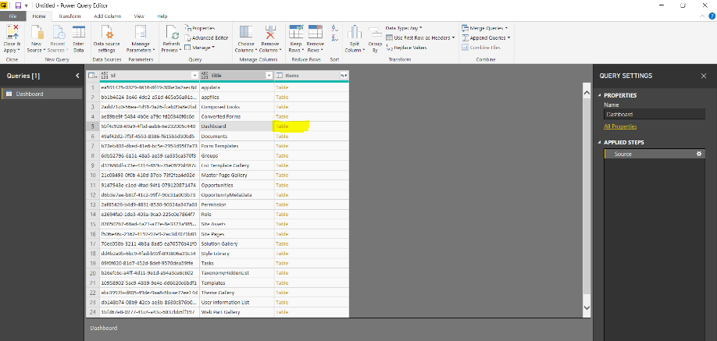

Click on the “Choose Columns”, will open window by default with all columns as selected

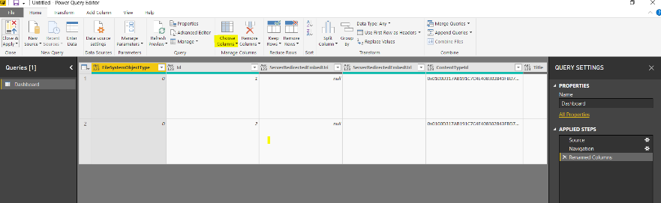

“uncheck” the select all checkbox to deselect all the columns and select below mentioned columns.

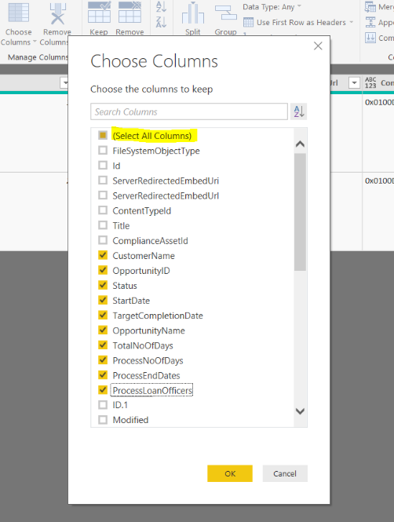

Select the “TotalNoOfDays” column->Transform -> change the “DataType” to “whole number”

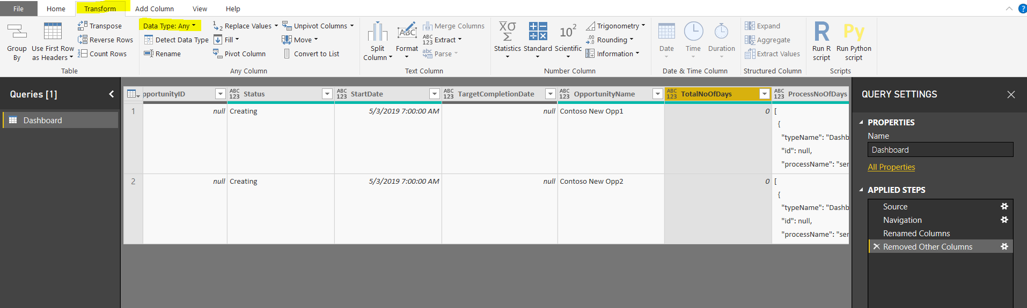

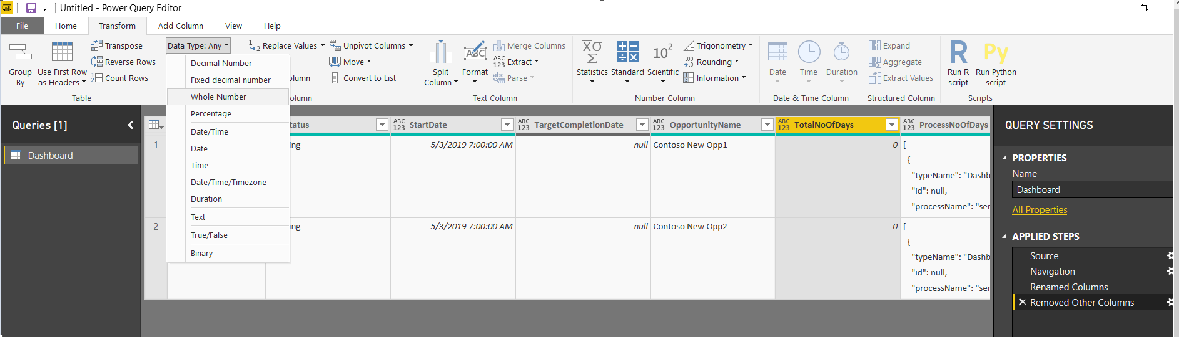

Select “ProcessNoOfDays” -> parse to “Json”

Repeat the same step for “ProcessEndDates”, “ProcessLoanOfficers”

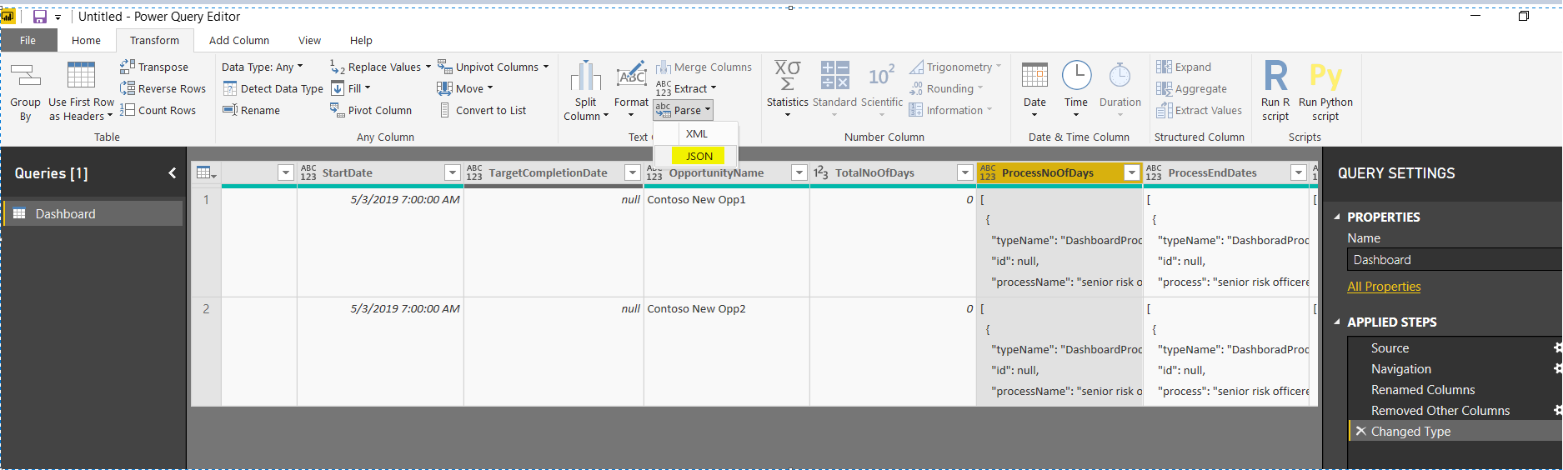

After converting 3 columns to JSON, list will look like below

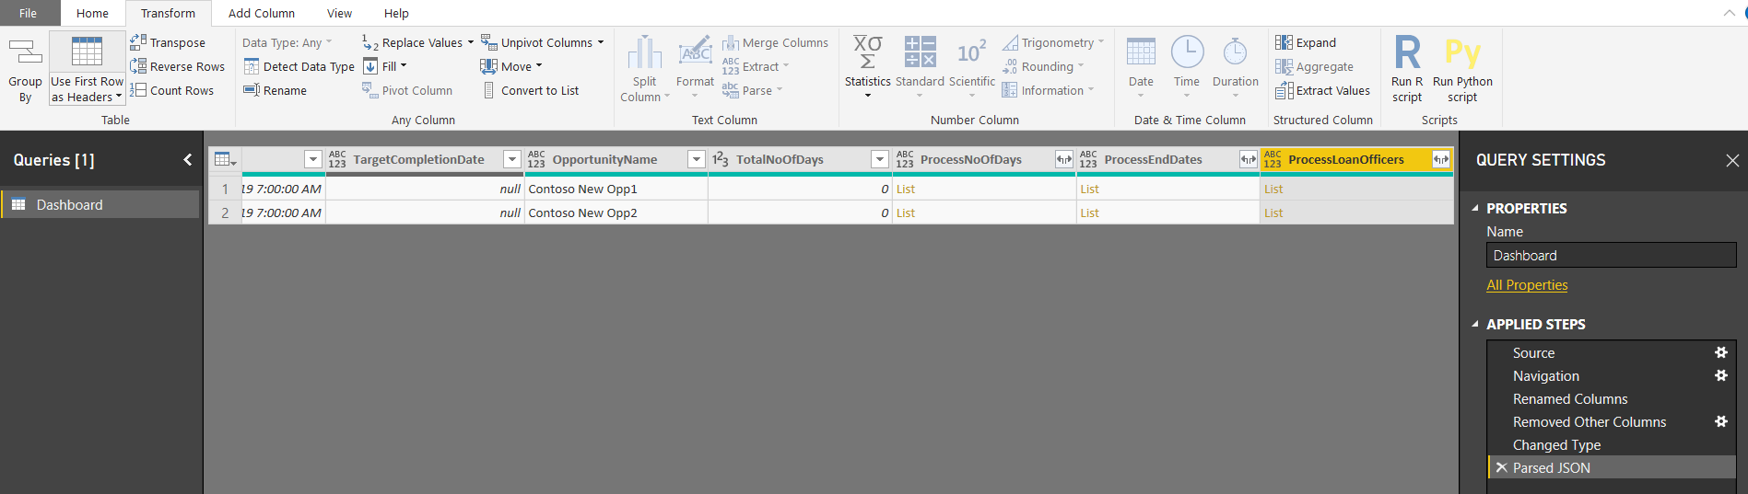

Select the “ProcessNoOfDays”, click on arrow icon next to heading -> click o “Expand to New Rows”

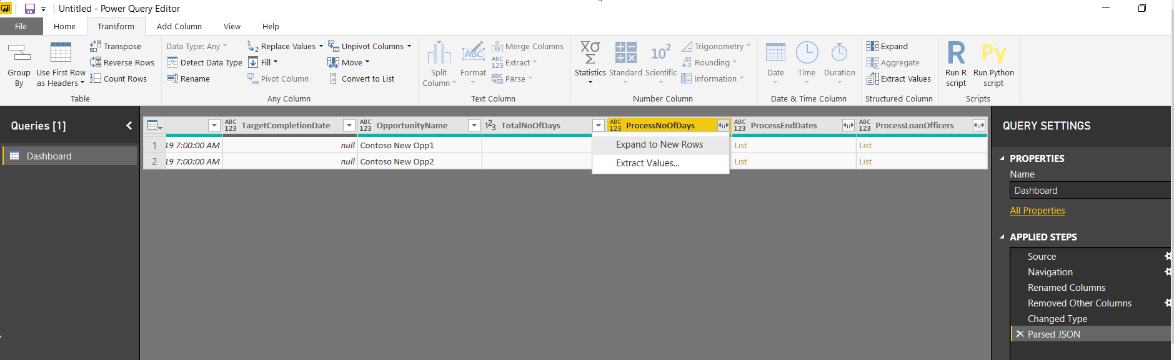

List will look like below

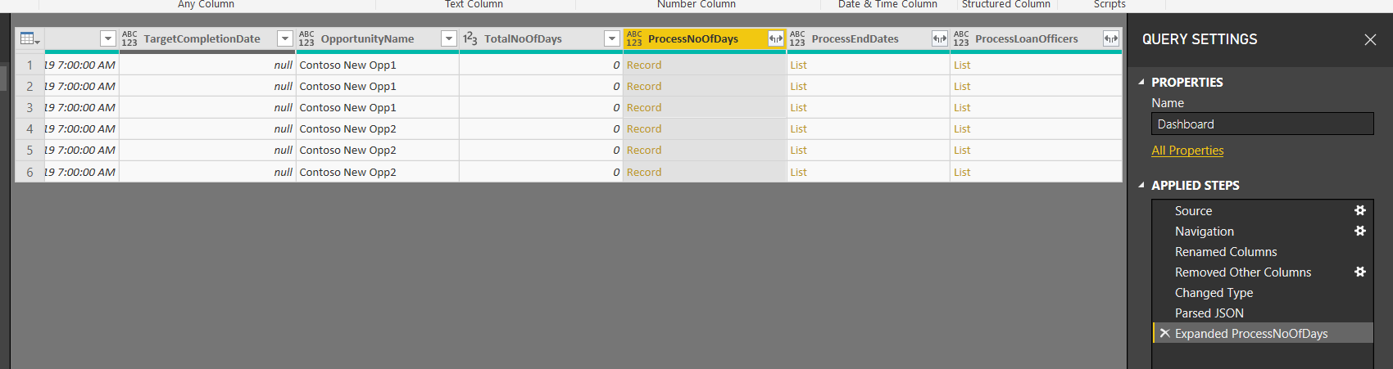

Select the column “ProcessNoOfDays” -> Click on arrow icon next to it.

Uncheck the “Select All Columns” check box and select the “ProcessName”, “noOfDays” columns. Click on “OK” button

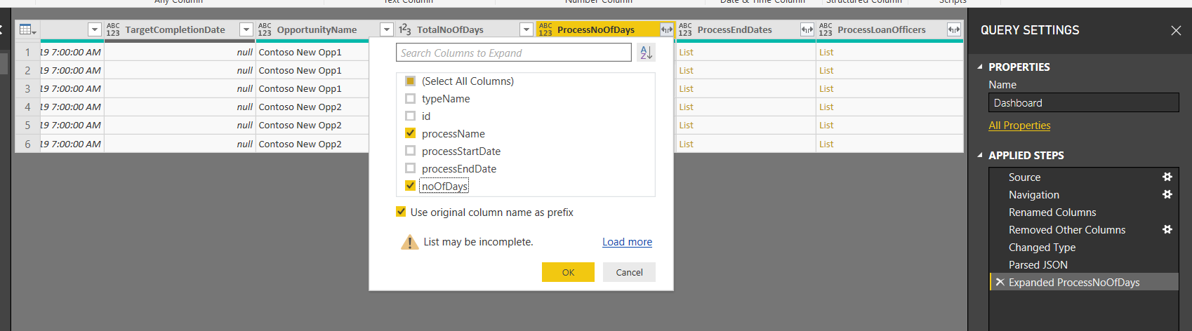

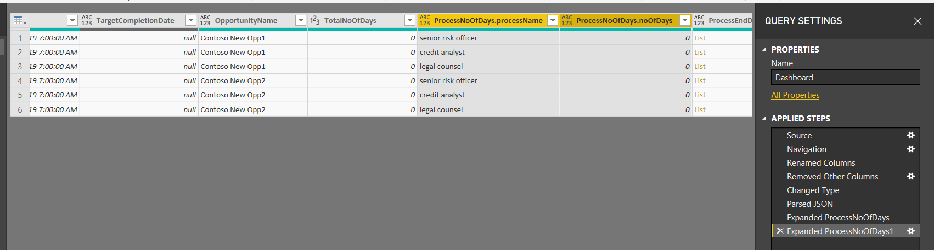

Select the “PRocessNoOfDays.processName” column, click on “Pivot Column”

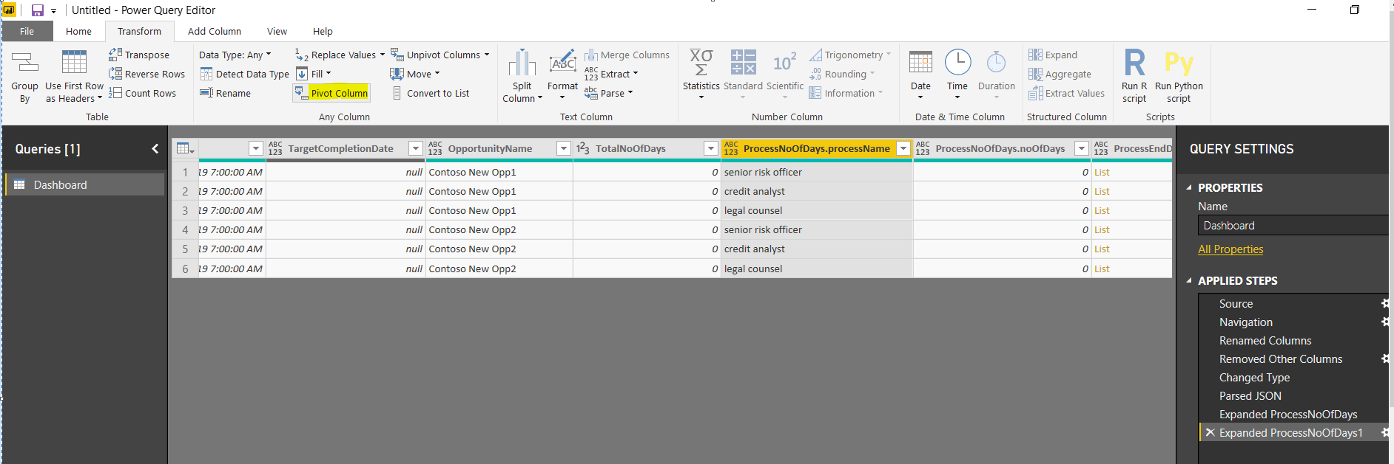

In Pivot Column window, select the “Values Column” as “ProcessNoOfDays.noOfDays” and expand the Advanced option -> Select “Aggregate Value Function” option as “Don’t Aggregate” -> Click on OK

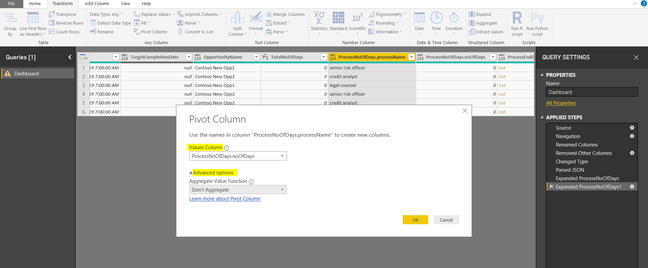

After this Process type column will display in table list with value 0.

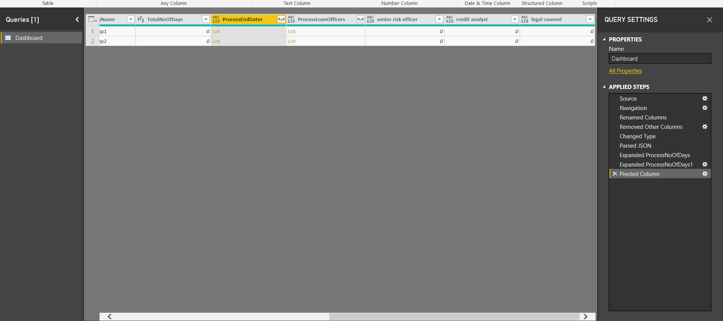

Select the column “ProcessEndDates” -> Click on arrow icon and click on “Expand to New Rows”

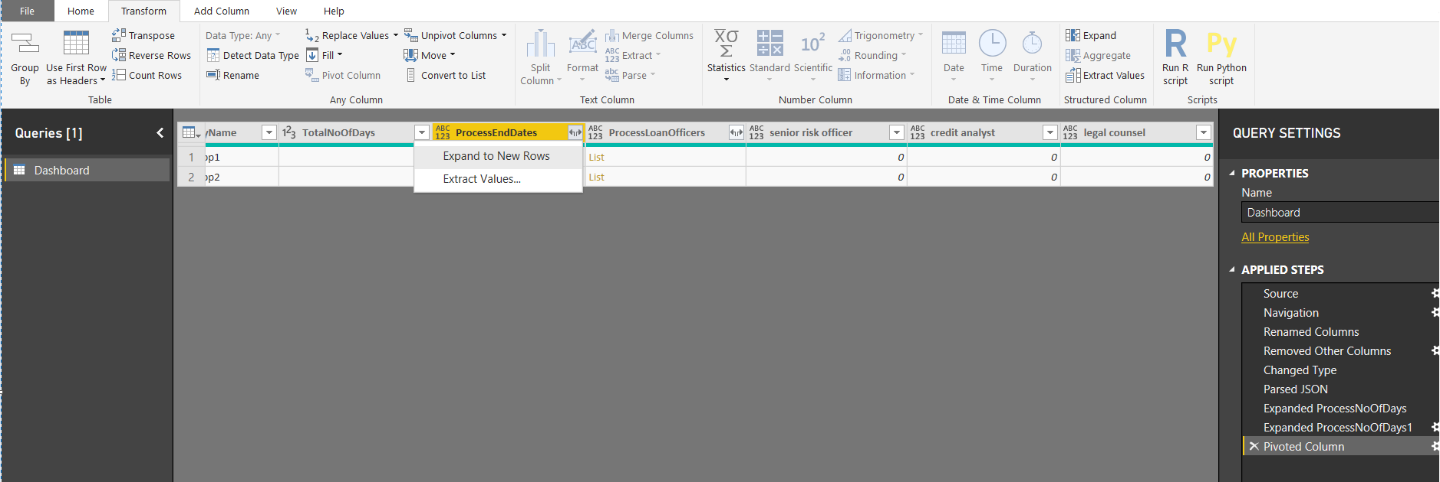

Click on Arrow icon next to “ProcessEndDates” column and select the below columns. Click on “OK” button

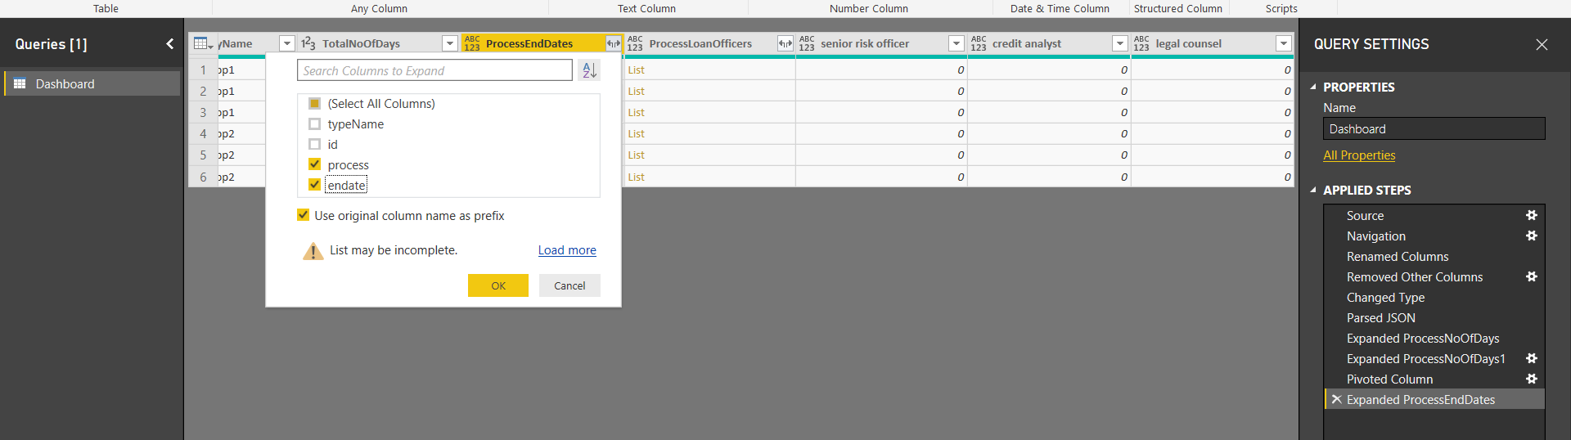

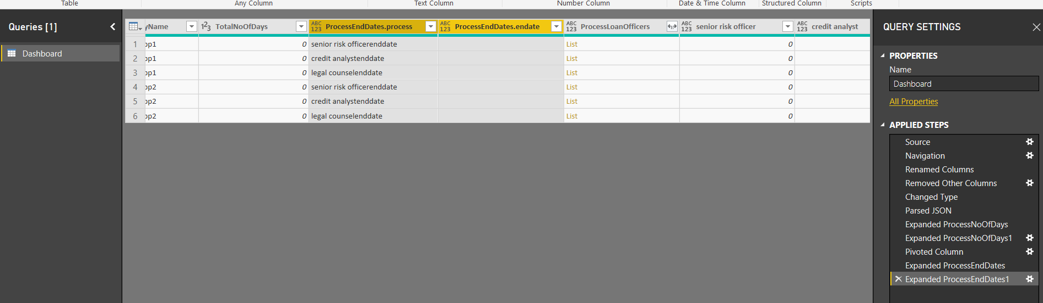

Select the “ProcessEndDates.process” column and click on “Pivot Column”

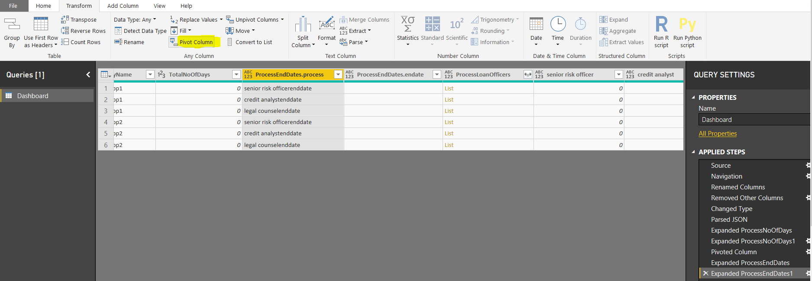

From the “Pivot Column” window, select the Values Column as “ProcessEndDates.endDate” and in advanced options -> Aggregate value function select as “Don’t Aggregate”

Click on “OK”

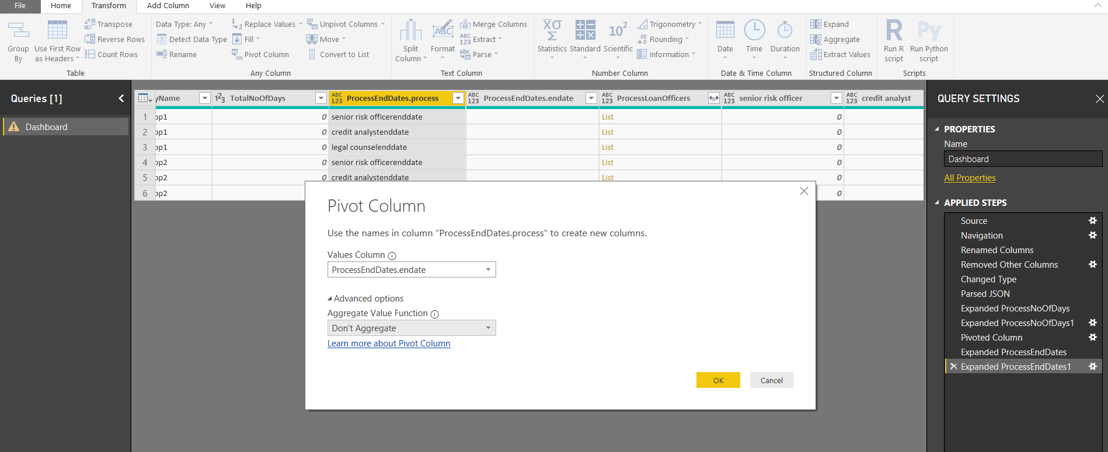

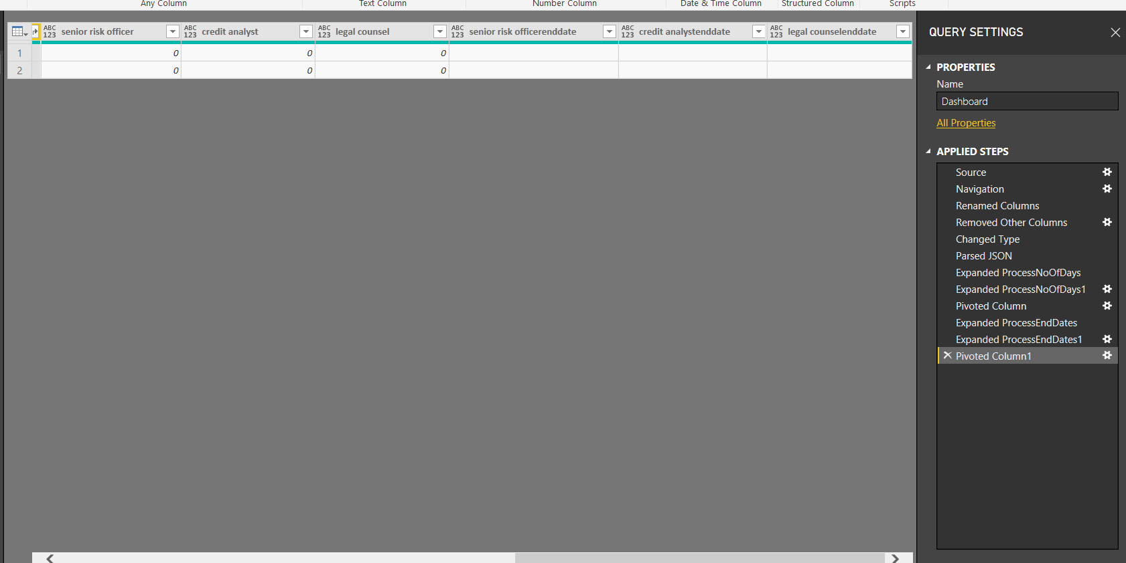

Select the <processname>endDate columns and change datatype to “Text” type.

Repeat the same step for all <processtype>enddate columns. (eg: senior risk officerenddate, credit analystenddate, legal counselenddate columns)

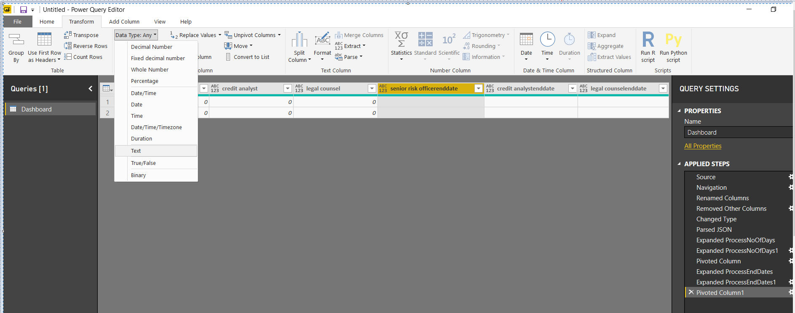

Select the column “ProcessLoanOfficers”, click on arrows-> Expand to new rows

Select the arrow again and select the columns “AdGroupName”, “OfficerName”

Click on “OK” button

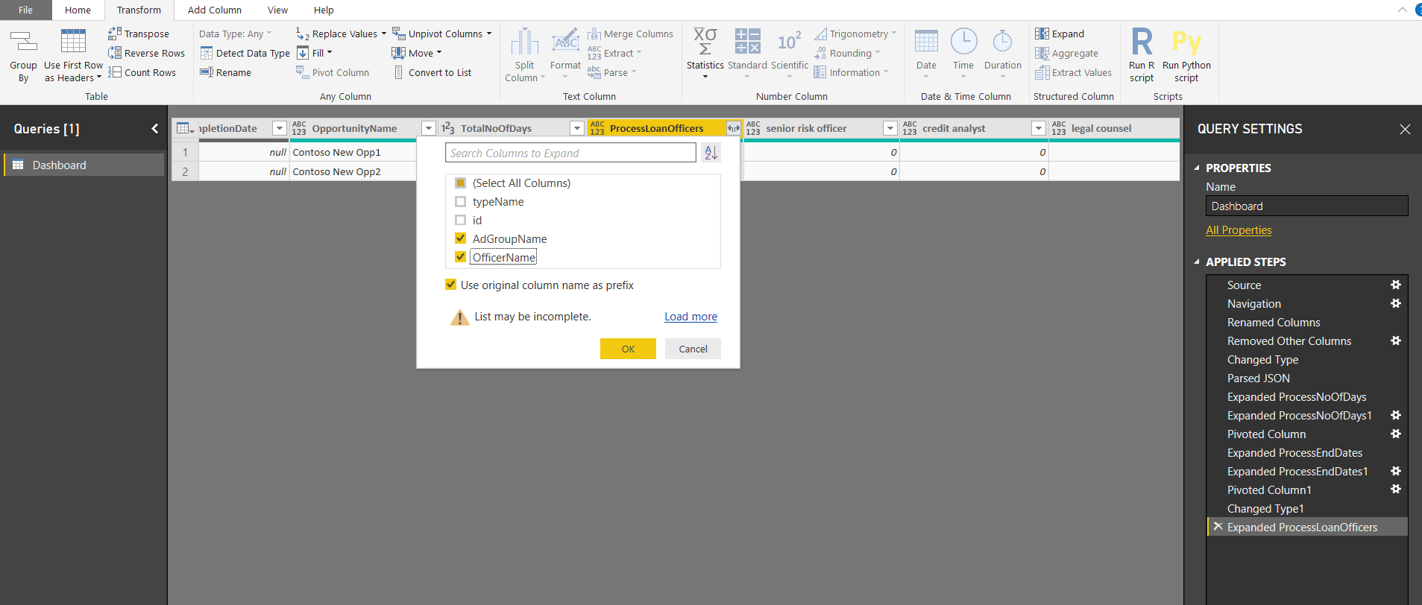

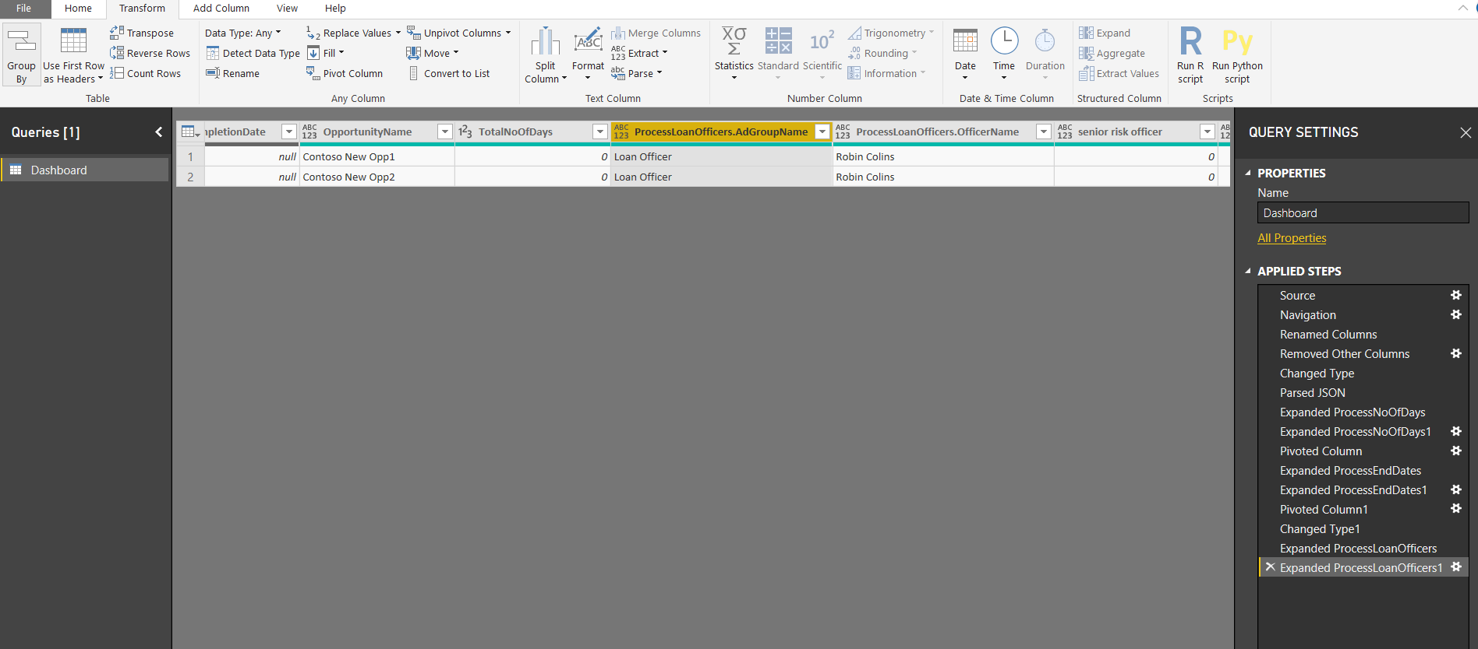

Select the column “ProcessLoanOfficers.AdGroupName”, click on “Pivot Column”

Select values column dropdown -> select “ProcessLoanOfficers.AdGroupName”

In advanced option -> Aggregate value function dropdown select “Don’t Aggregate”-> Click “OK”

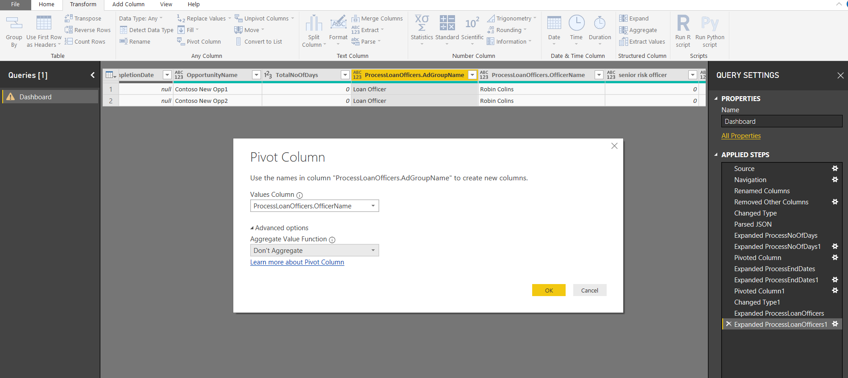

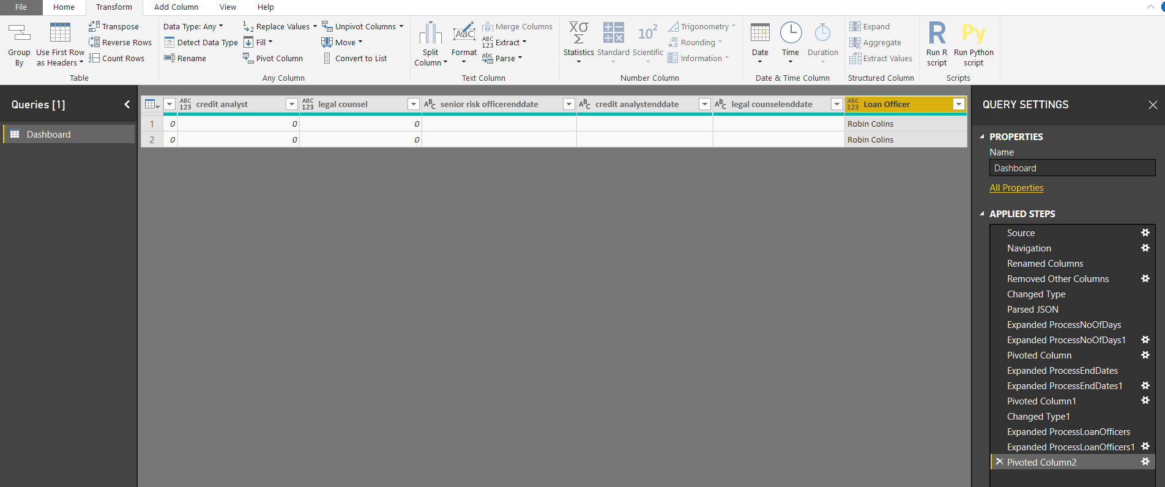

Select the column “Loan Officer” change the “Data Type” to “text”

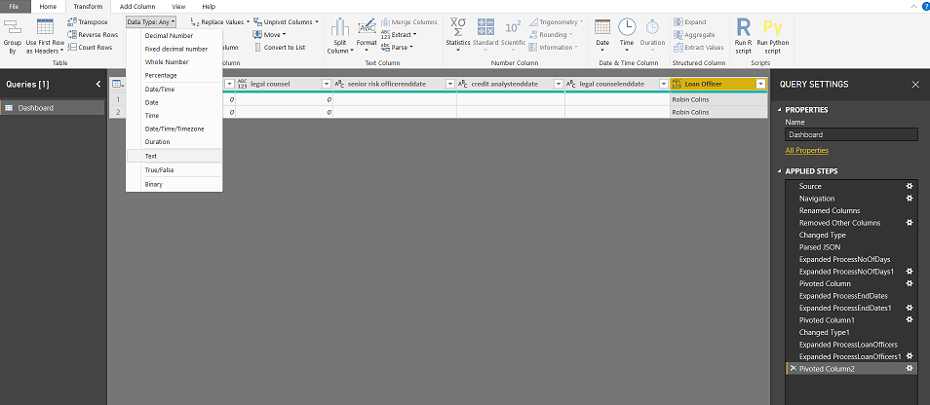

Click on “File” -> Select “apply”

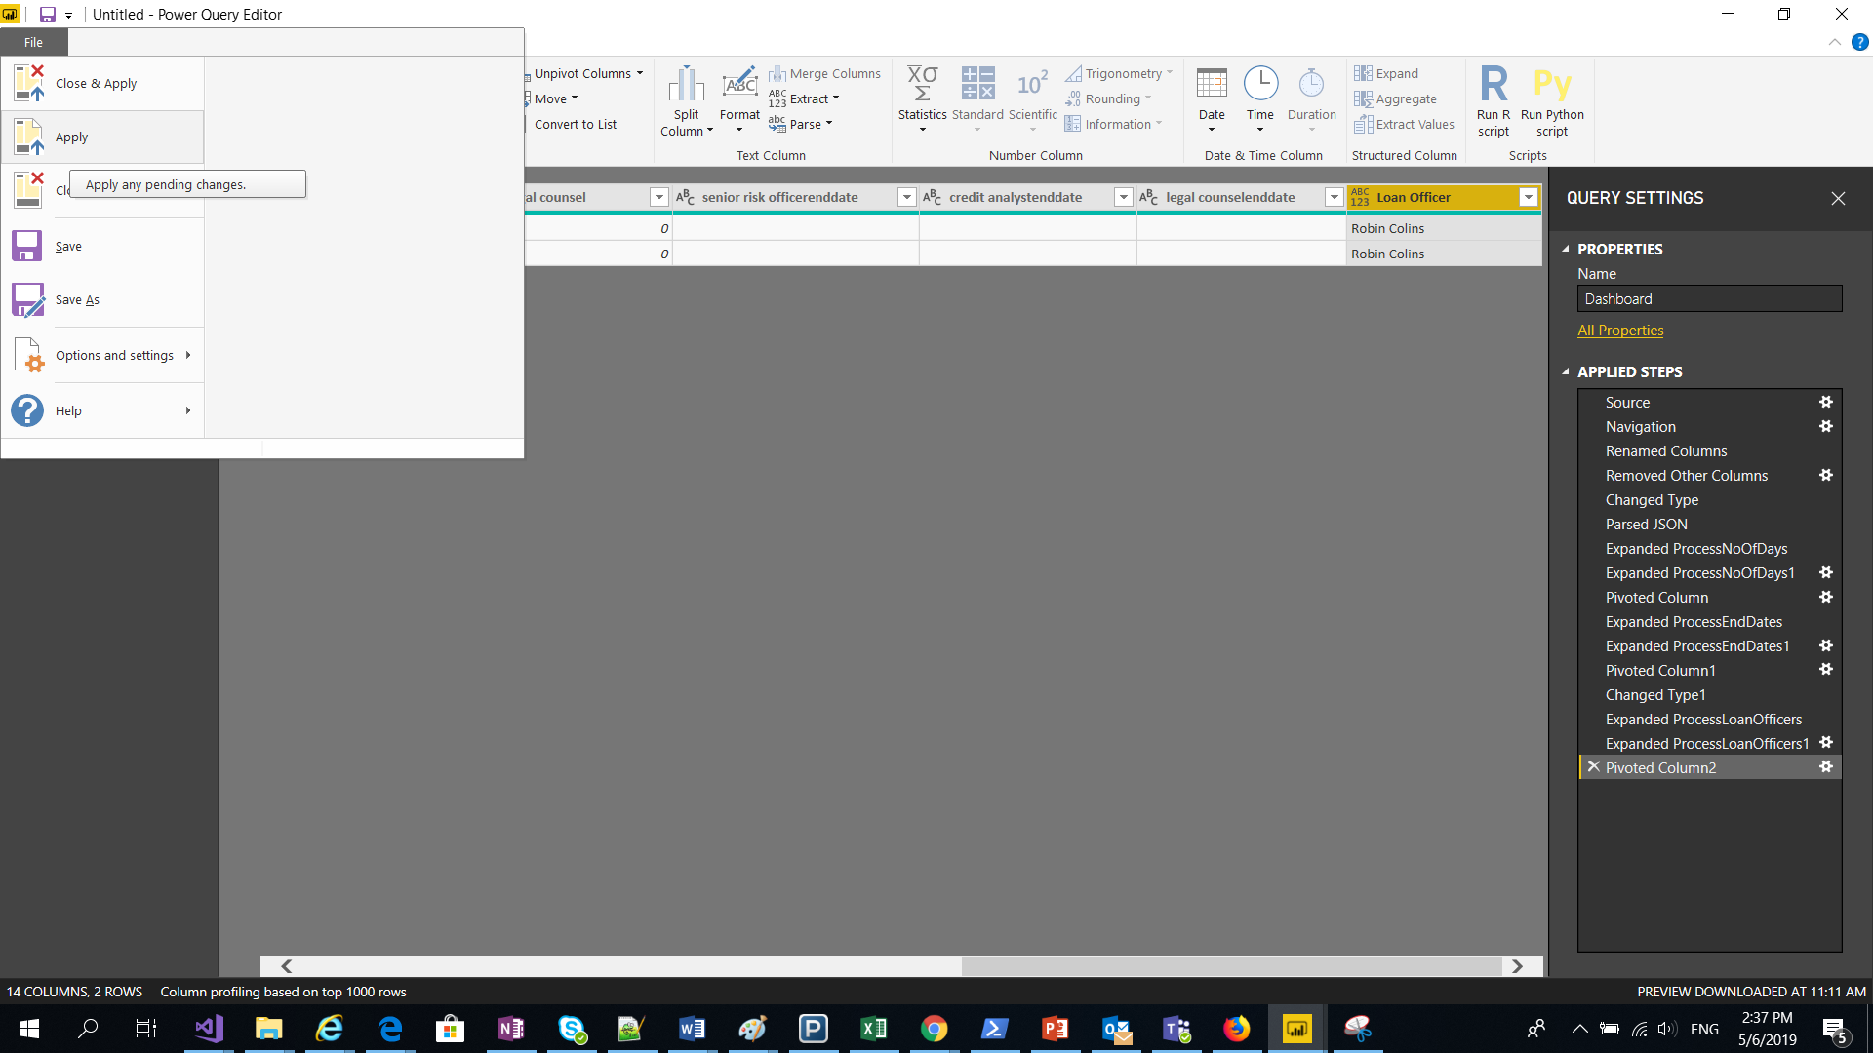

Select all the <processtype> columns and change datatype to “Whole Number”

(here process types are: Senior risk officer, credit analyst, legal counsel)

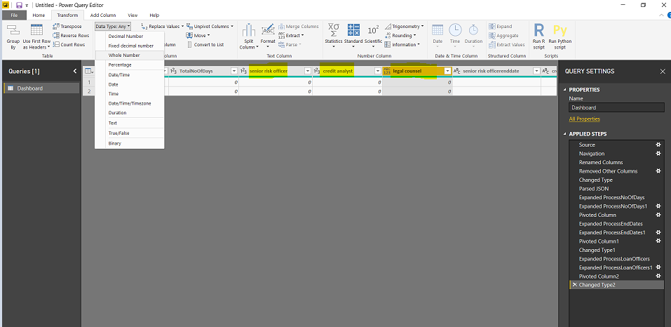

Click on “Refresh” in PowerBI app

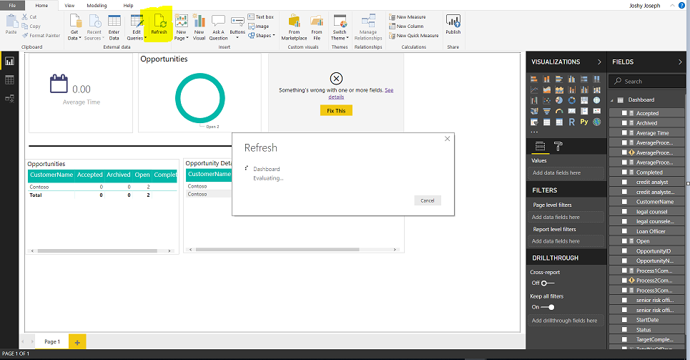

After the refresh power BI report will look like below.

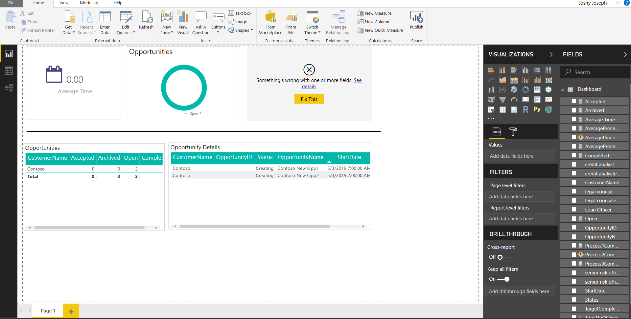

See the fields in right hand side and clear the error by changing the proper process column names. (Process1CompletedCount, Process2CompletedCount, Process3CompletedCount)

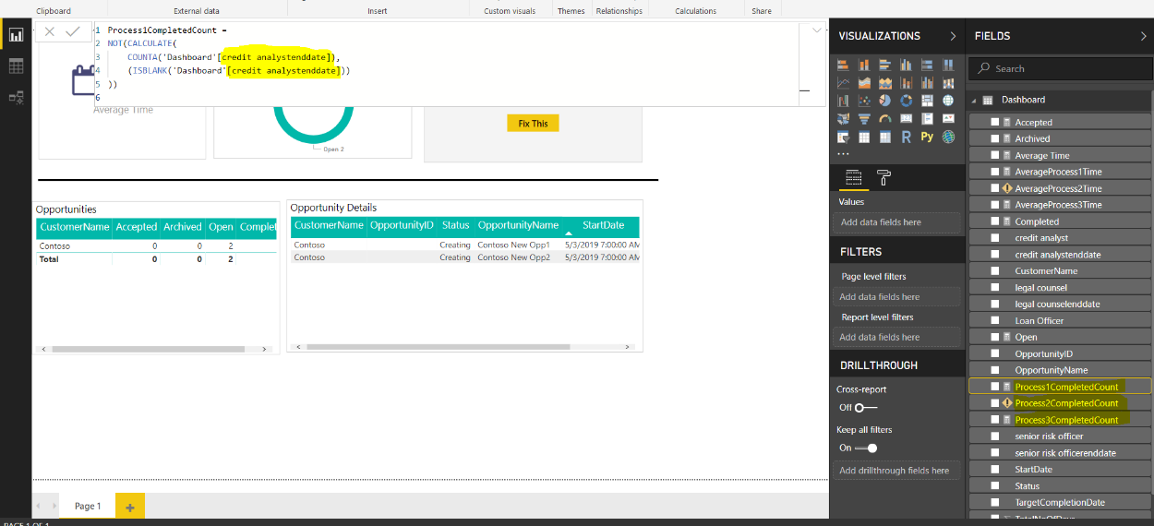

See the fields “AverageProcess1Time”, “AverageProcess2Time”, “AverageProcess2Time”, and update the correct <processtype> in formula bar. Click on “Apply” or “  ” symbol.

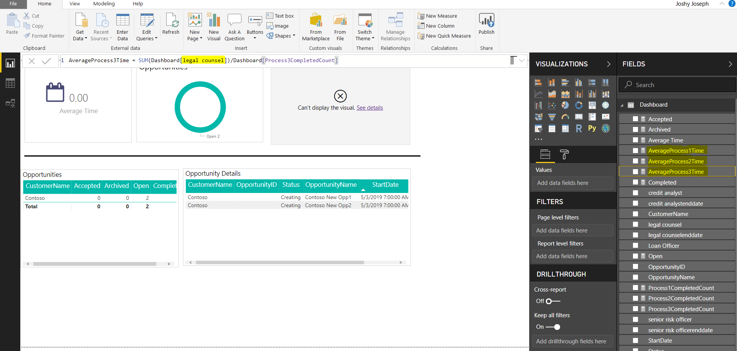

Click on “Refresh” icon to refresh the chart. Report will be seen like below.

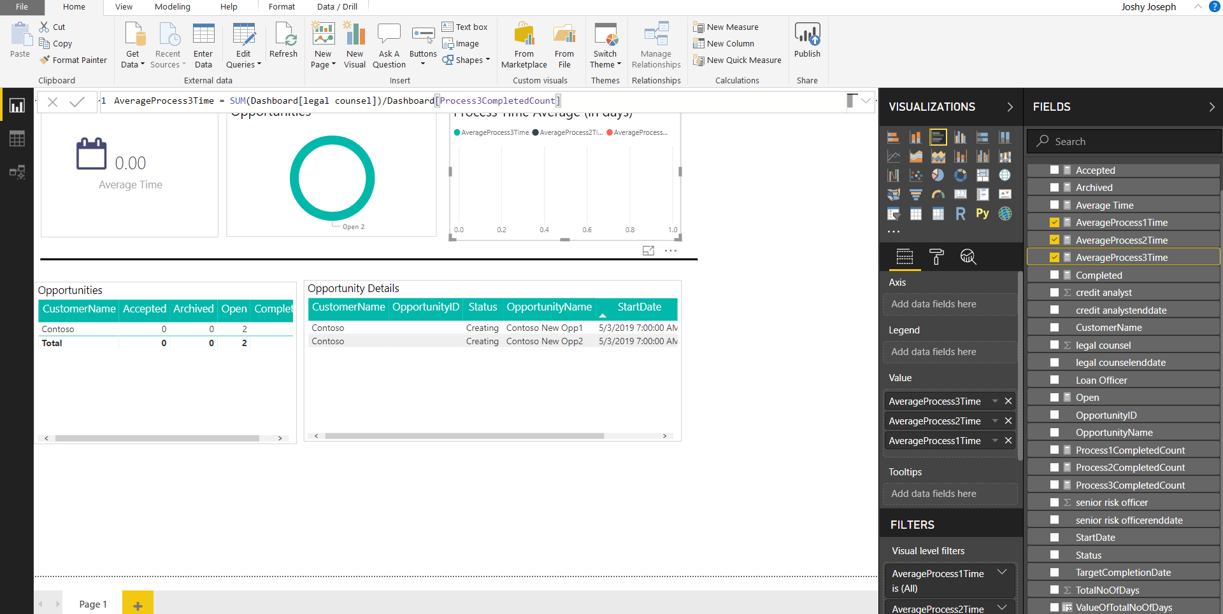

By click This report you can publish to powerbi online. Before publishing make sure that you have logged-in to powerbi with admin credentials.

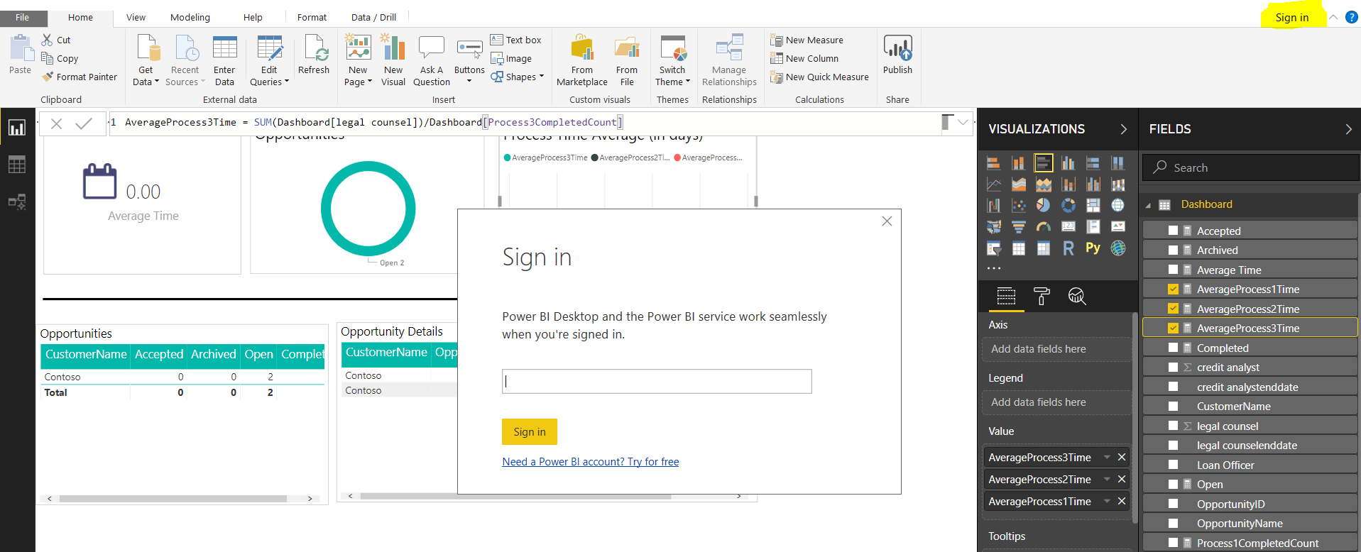

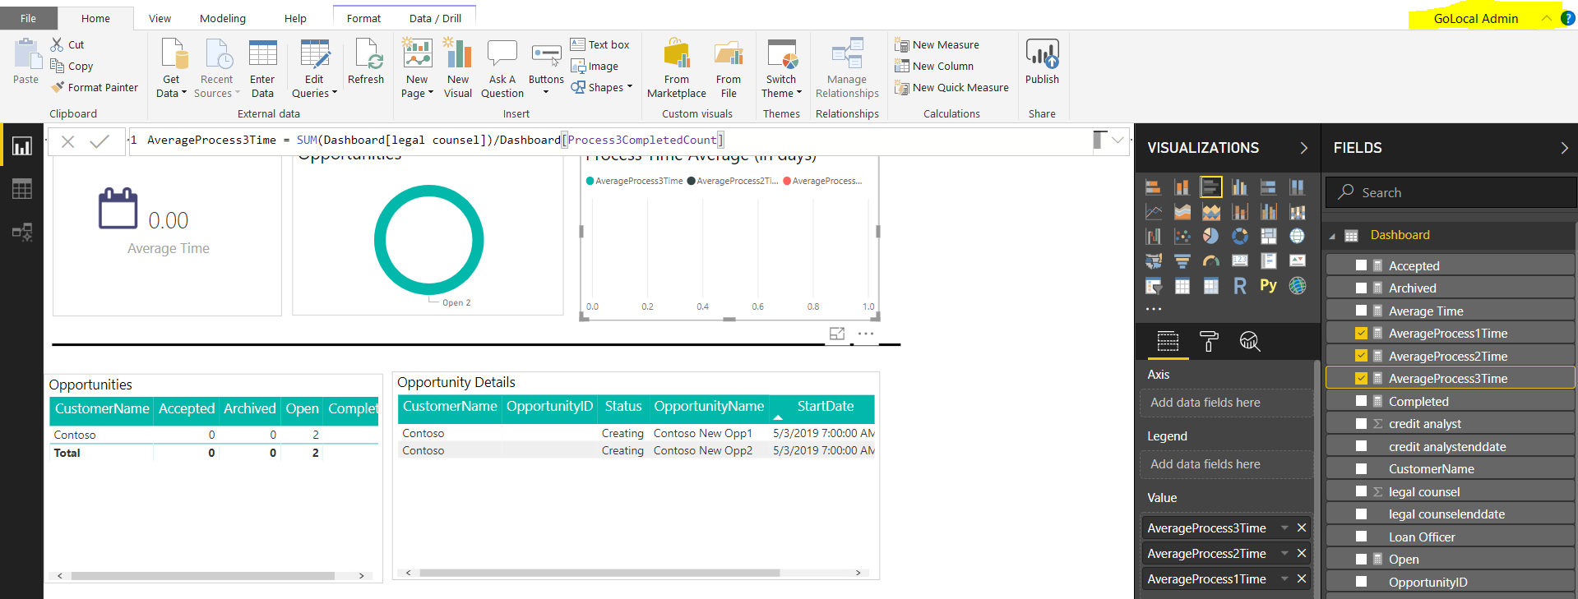

Publish the report to workspace

Then complete the “Configure PowerBI”

Login to teams, access the general proposal manager app -> select the “General” channel and click on “Dashboard” tab. It will load the PowerBI report.

